Chimp Andy’s Resources

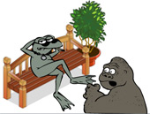
TASK 1

Chimp Andy is expecting you to create a spreadsheet and calculate how much money he has invested in his ‘resources’

STAGE 1

1. Set up a spreadsheet using the information below.

Item | value | number | Total value
Baseball bat | 15.25 | 12
Rope | 4.45 | 8
Masks | 9.39 | 12
Swag bag | 14.87 | 6
Axe | 29.53 | 3
 |  | Grand total

2. Save the spreadsheet to your area and give it a sensible name (Gangsta Zoo.xls)

